Android

Android operating system is a stack of software components which is roughly divided into five sections and four main layers as shown below in the architecture diagram.

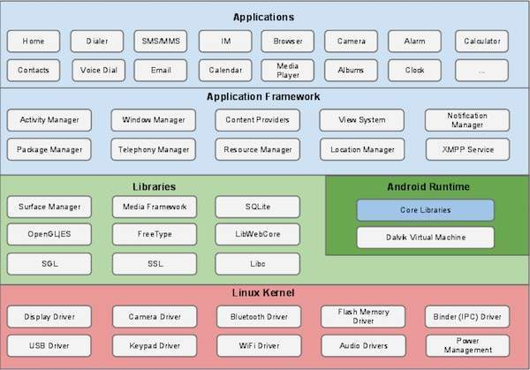

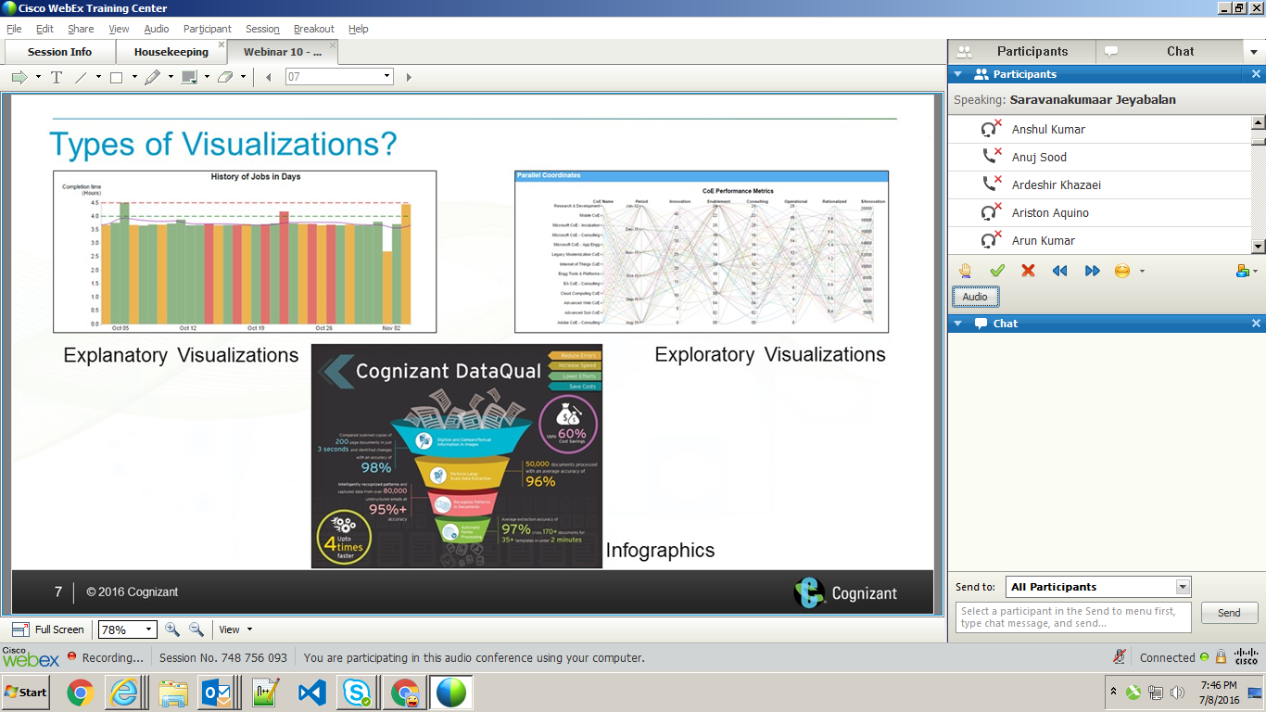

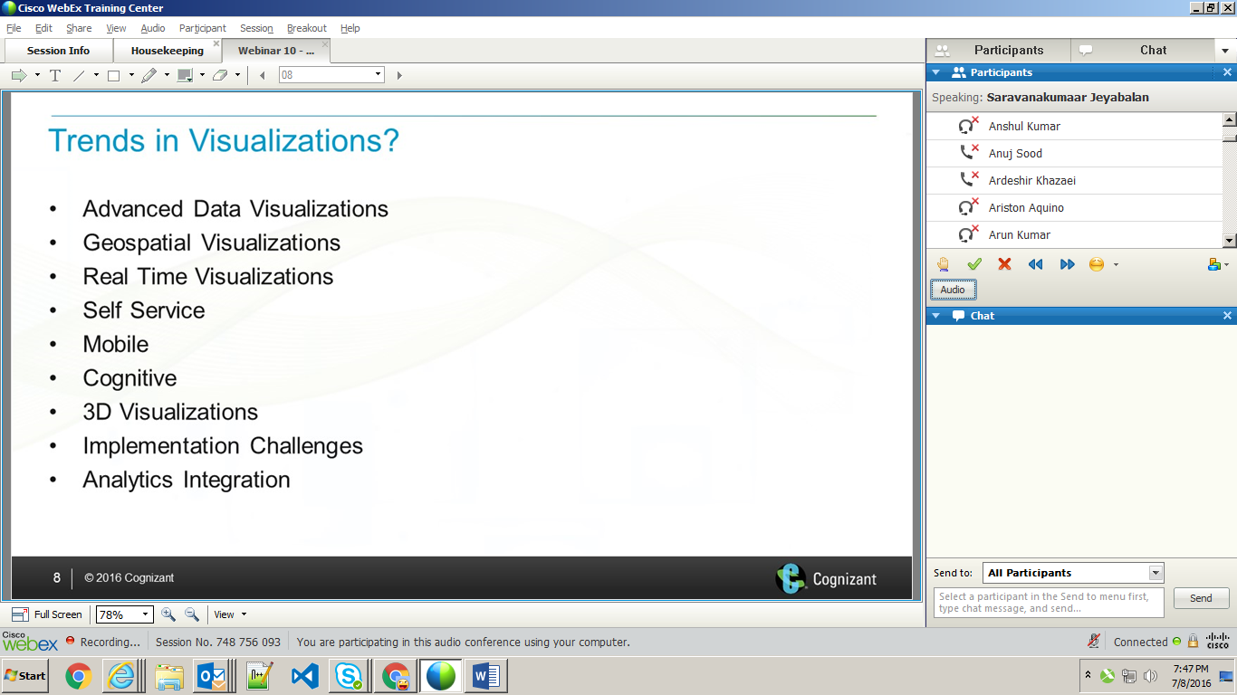

1. Advanced data vis : Bring more dimensions

Attributes : Combining more dimensions, Adding more colors..

1. How you can represent in map
2. Unstructured data. Eg. Events are represented
3. Power user can do it
4. Vis can represent in mobile devices
5. Self service and system learns and will help us in future
6. Can reprent floor, human body etc,
7. All data we couldn’t handle in local. So go for online.
8. To handle huge data we are going for analytics. Representing the data in human readable way. Analytics engine will be the part of visualization.

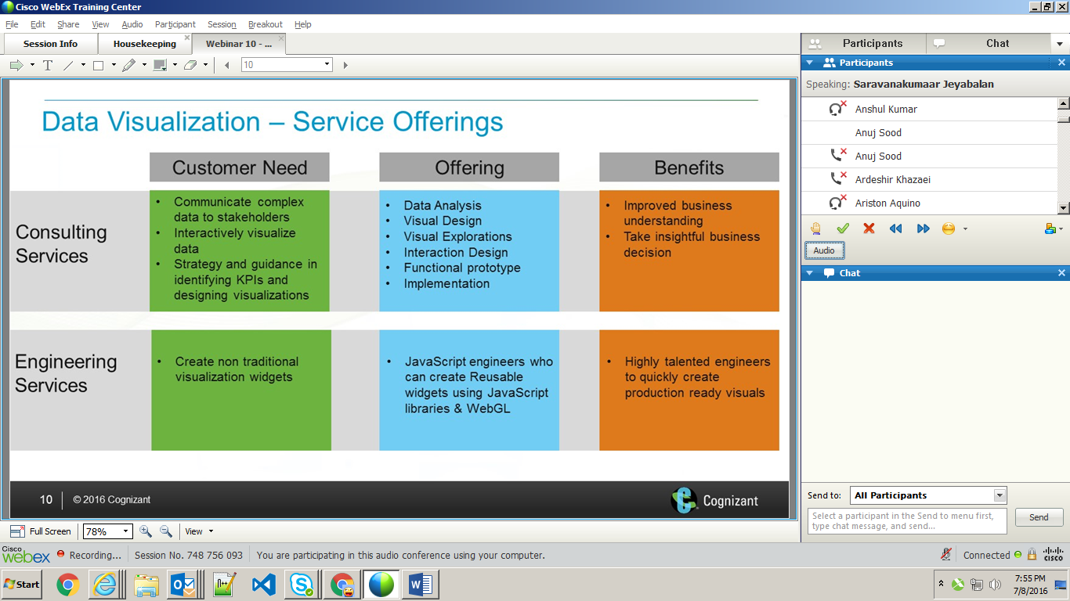

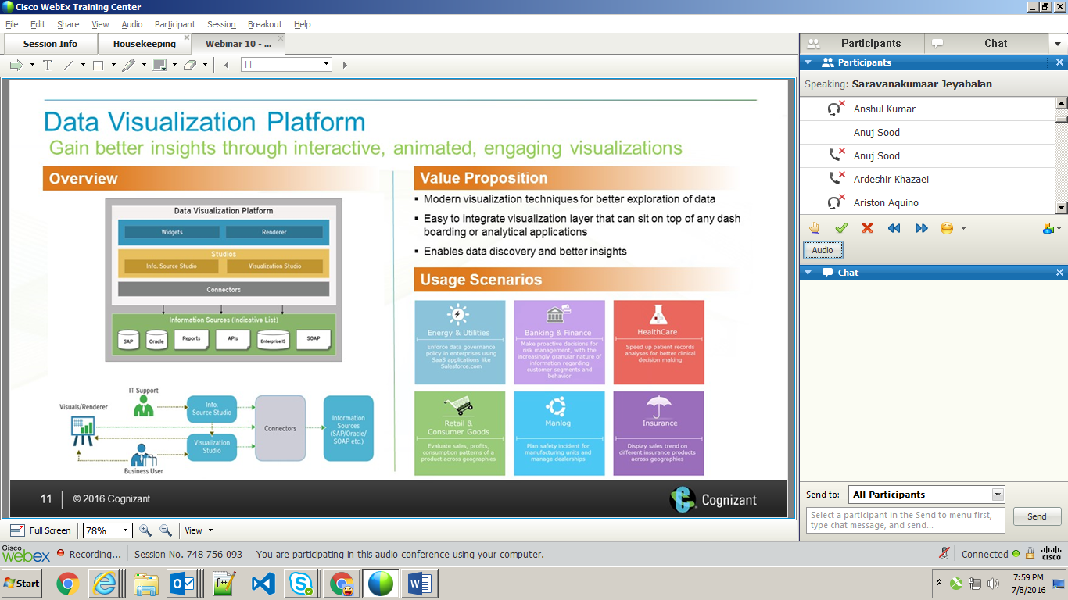

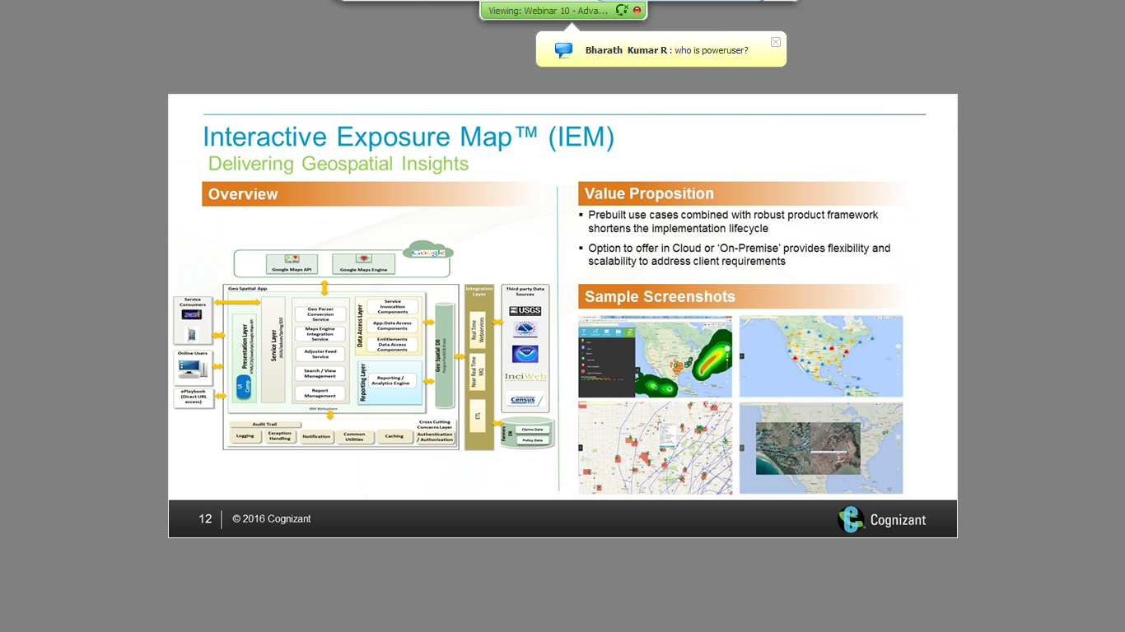

Phoenix – Data visualizer. Free for cognizant users and if it is the customer need, license agreement has to be signed and it is paid for them.

Restful, rdbms, excel upload/ download, web services and mongo db supports can be provided. Connected to SAP backend system.

Providing engineering support to American axes and support to Walmart(client)

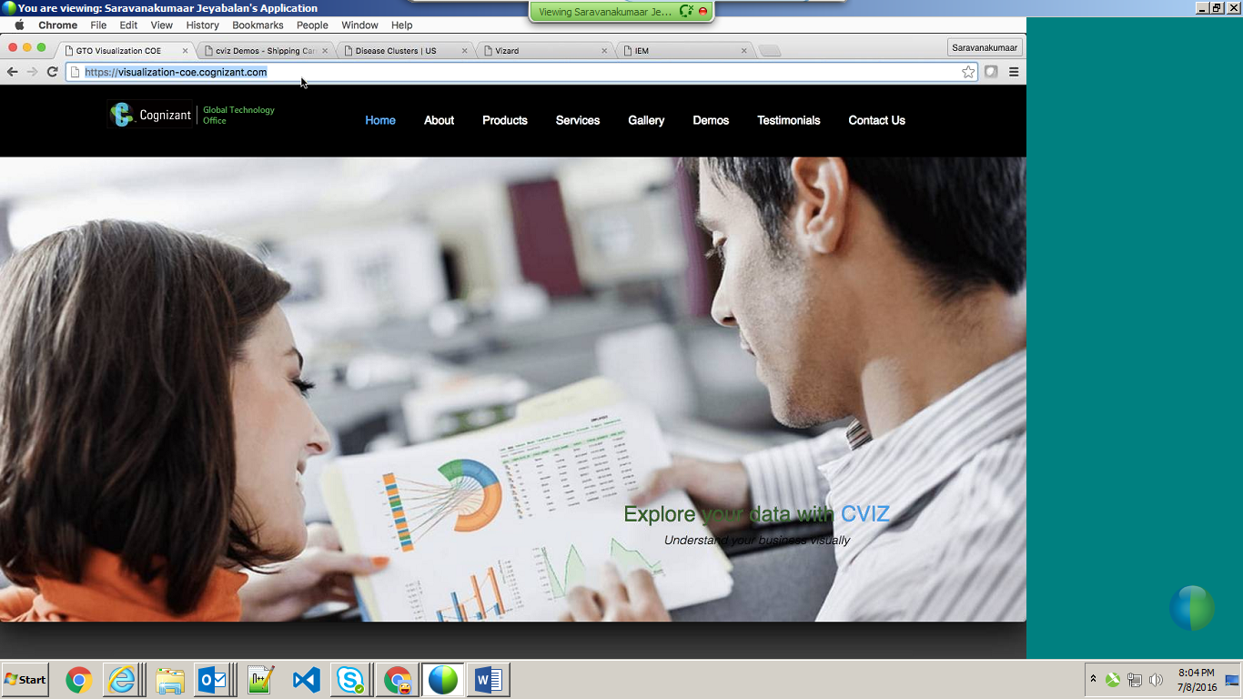

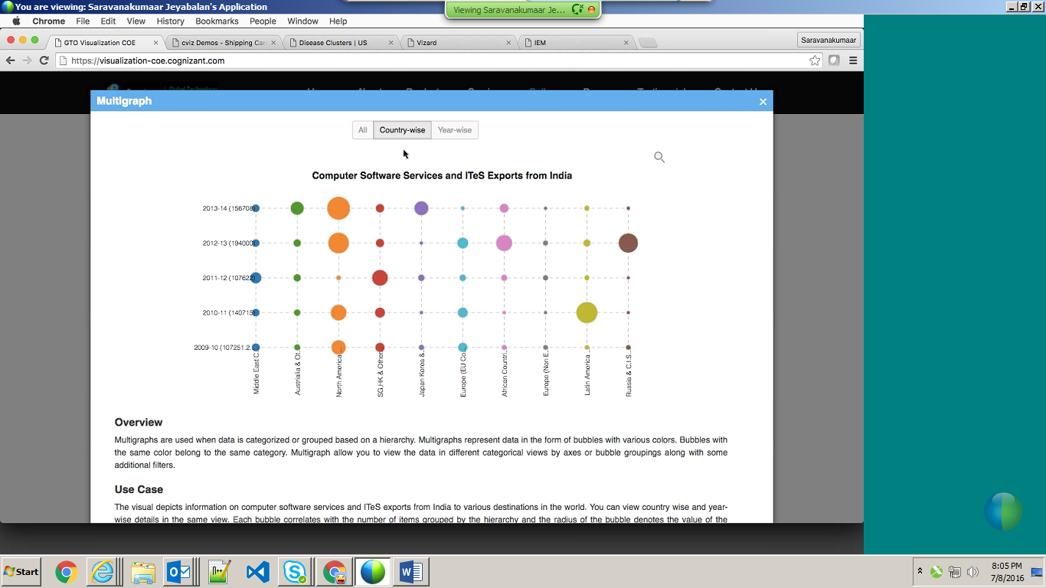

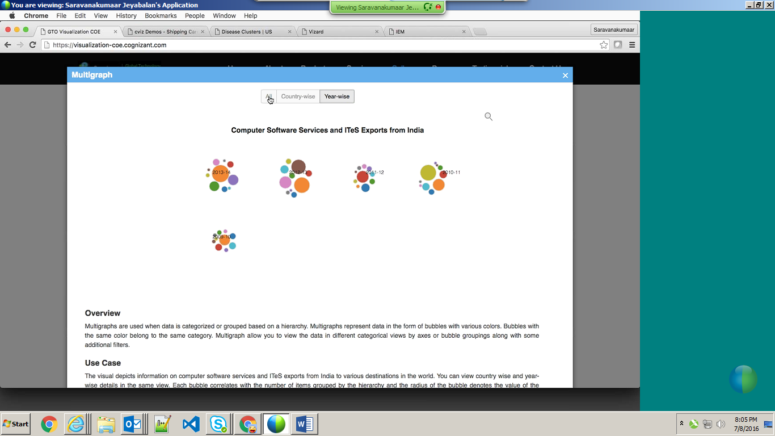

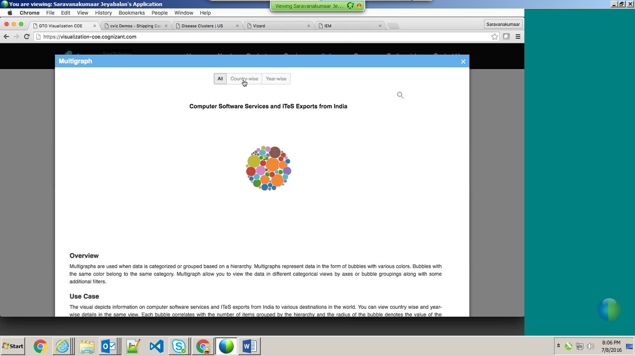

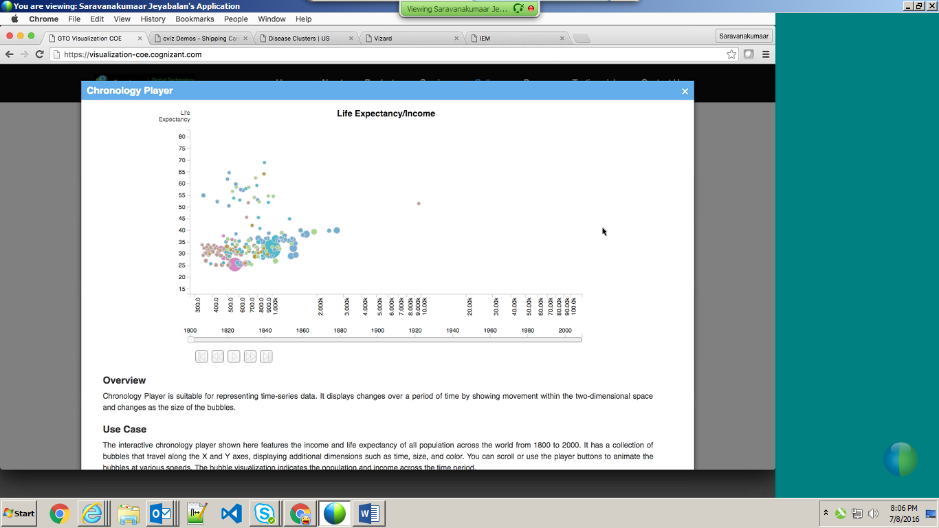

Used pure java script technology.

Play is working fine here - down.

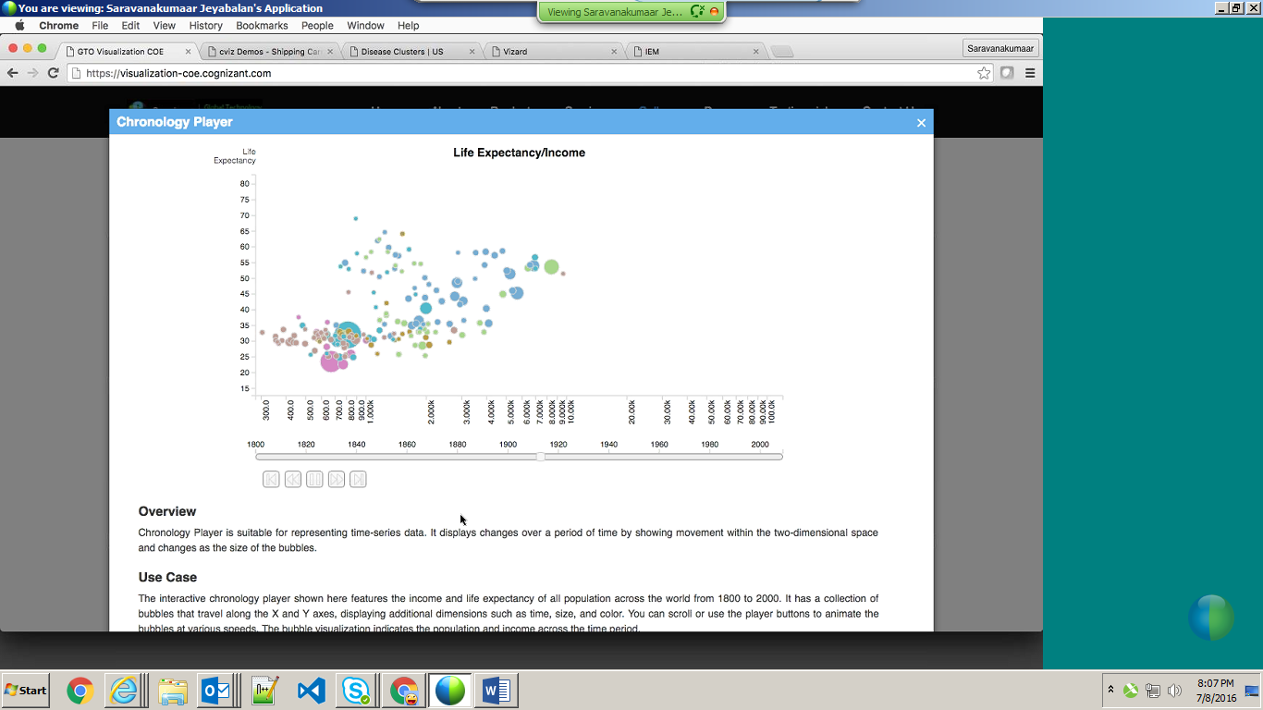

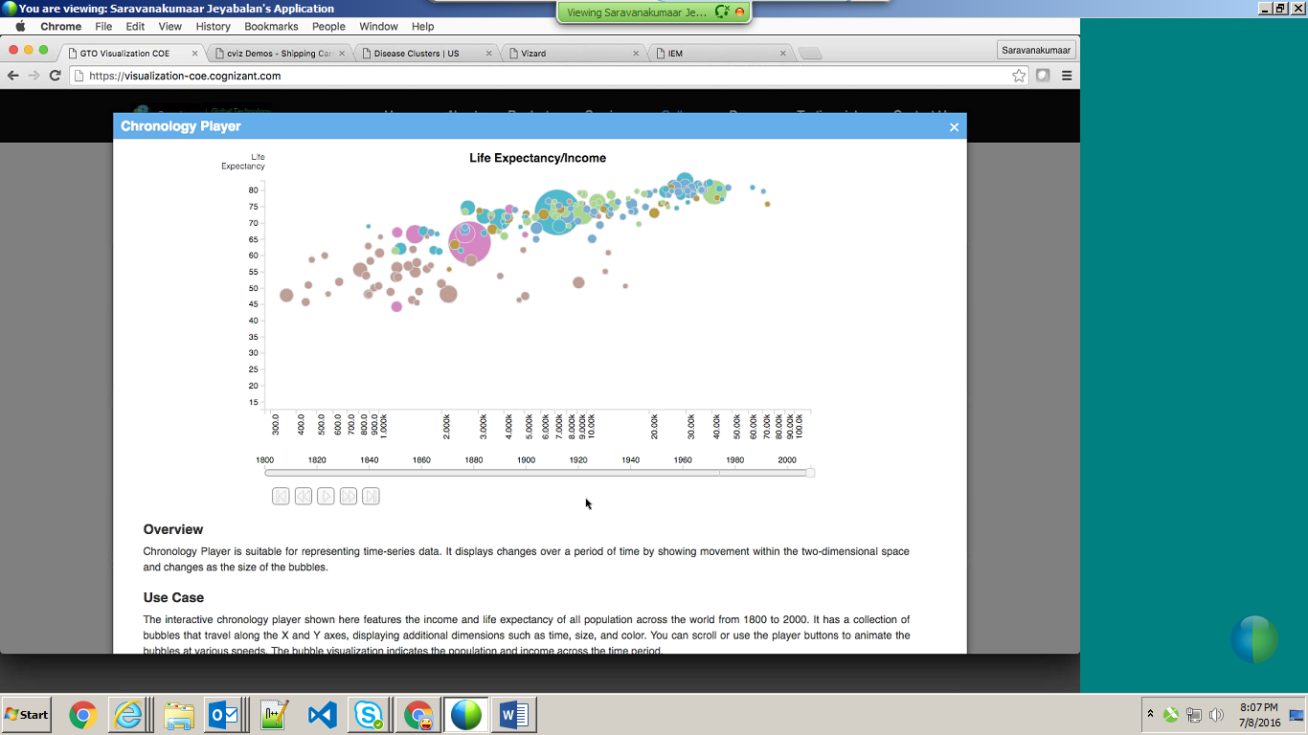

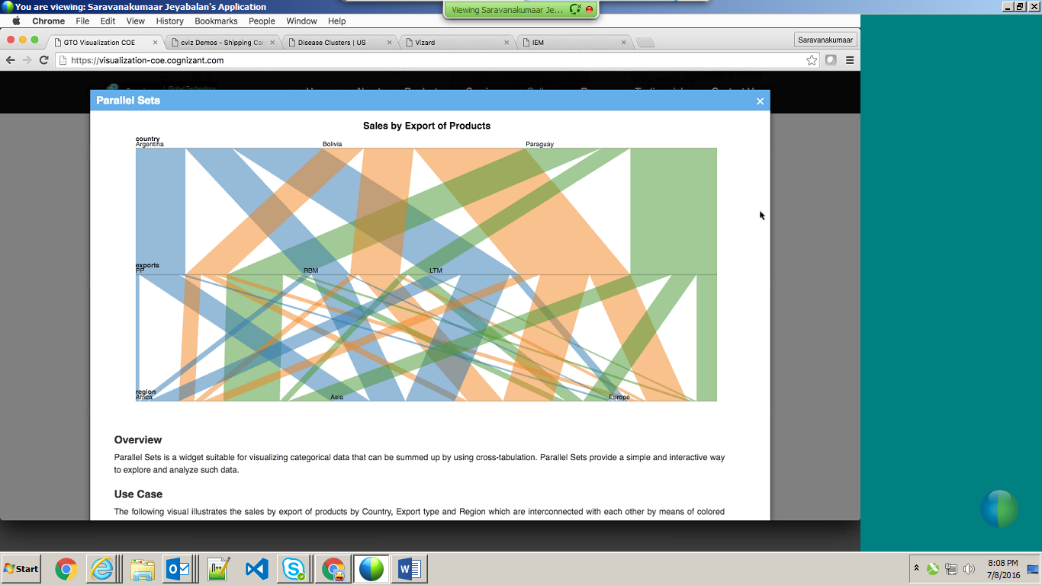

Can move the control.

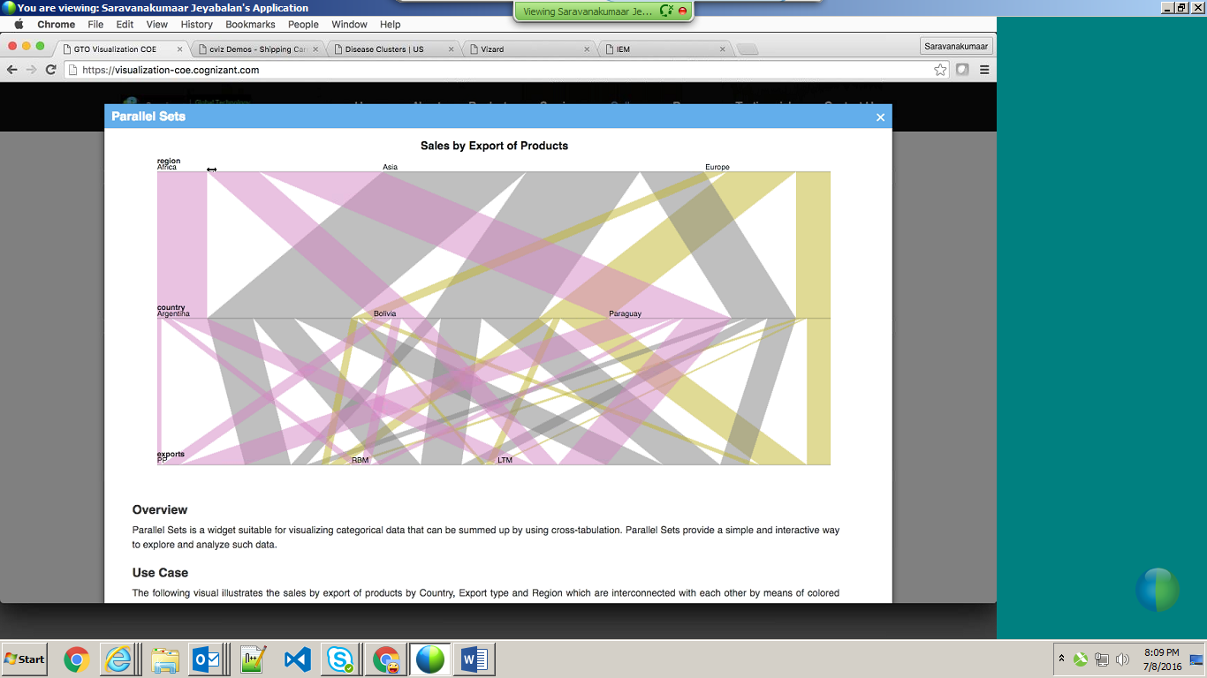

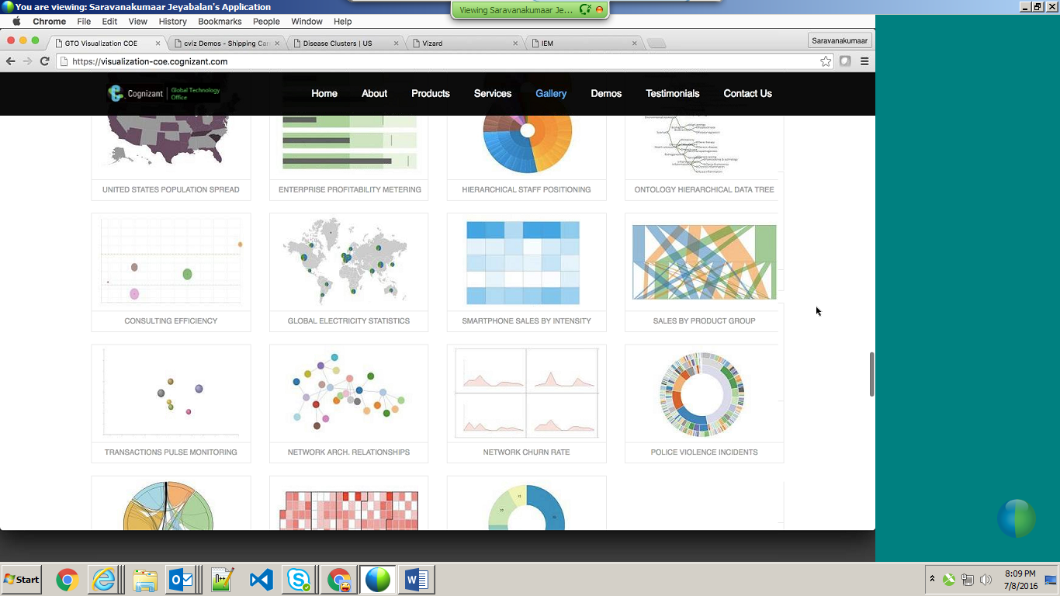

For one client.

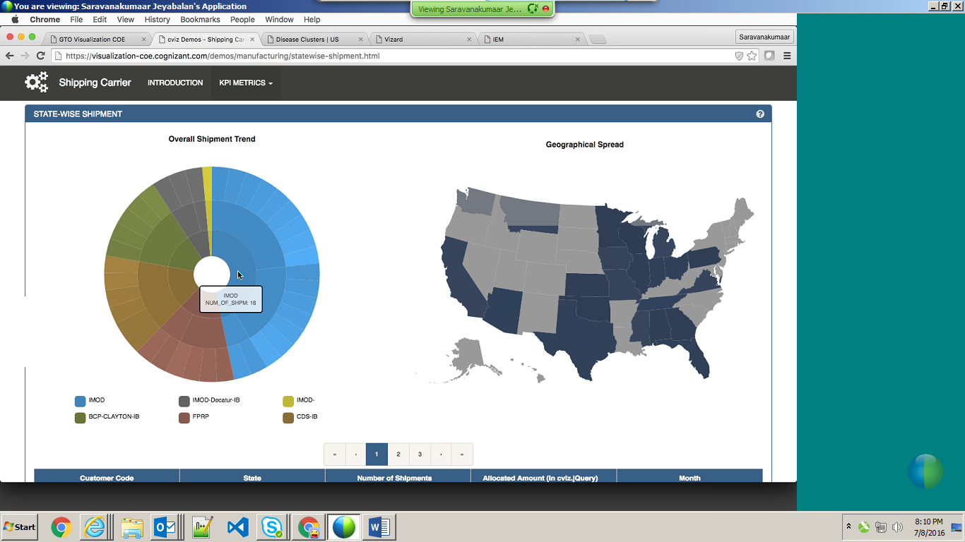

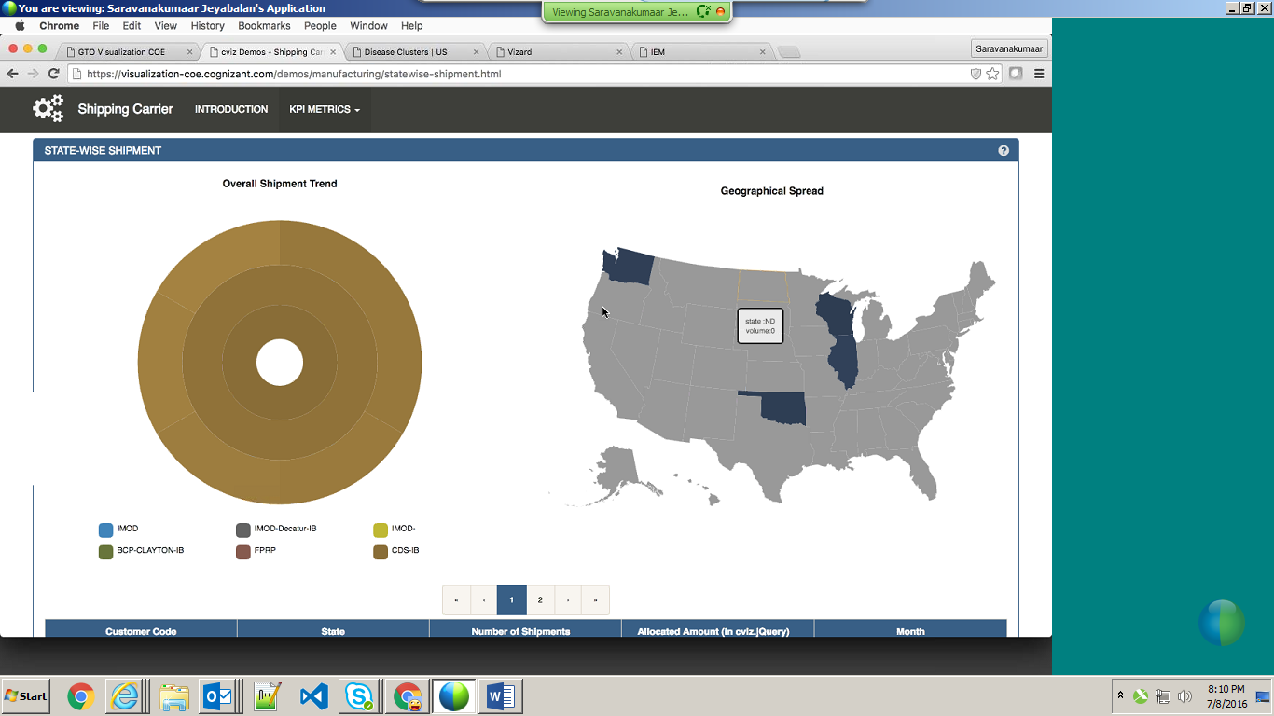

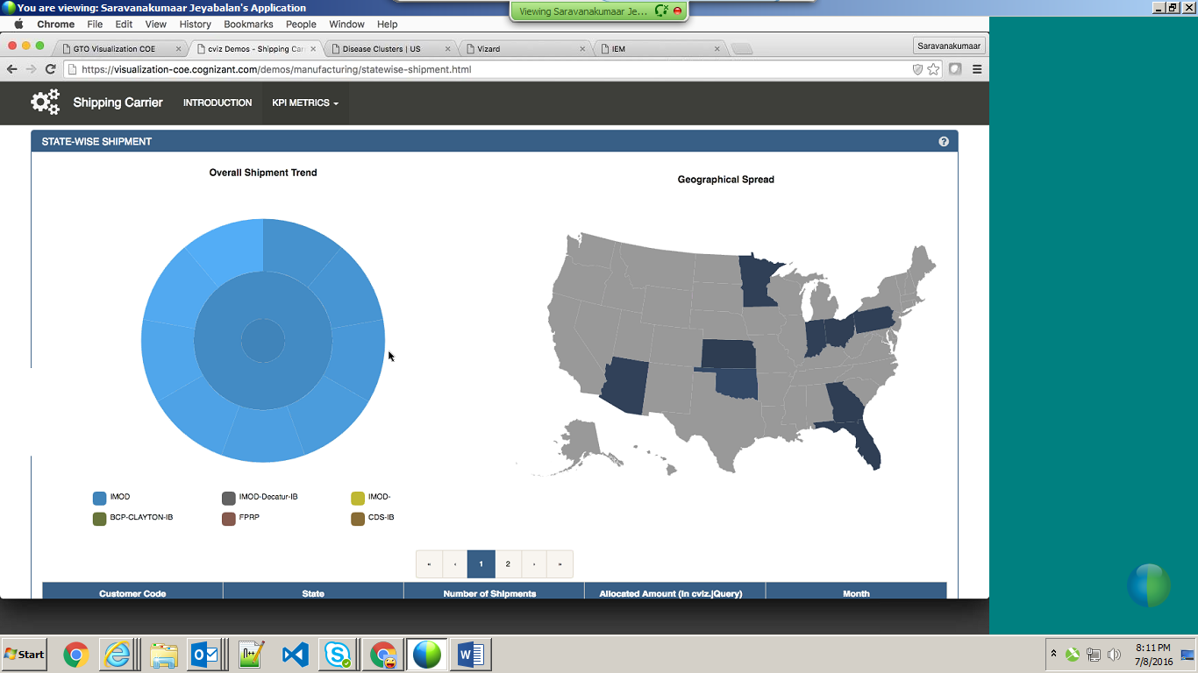

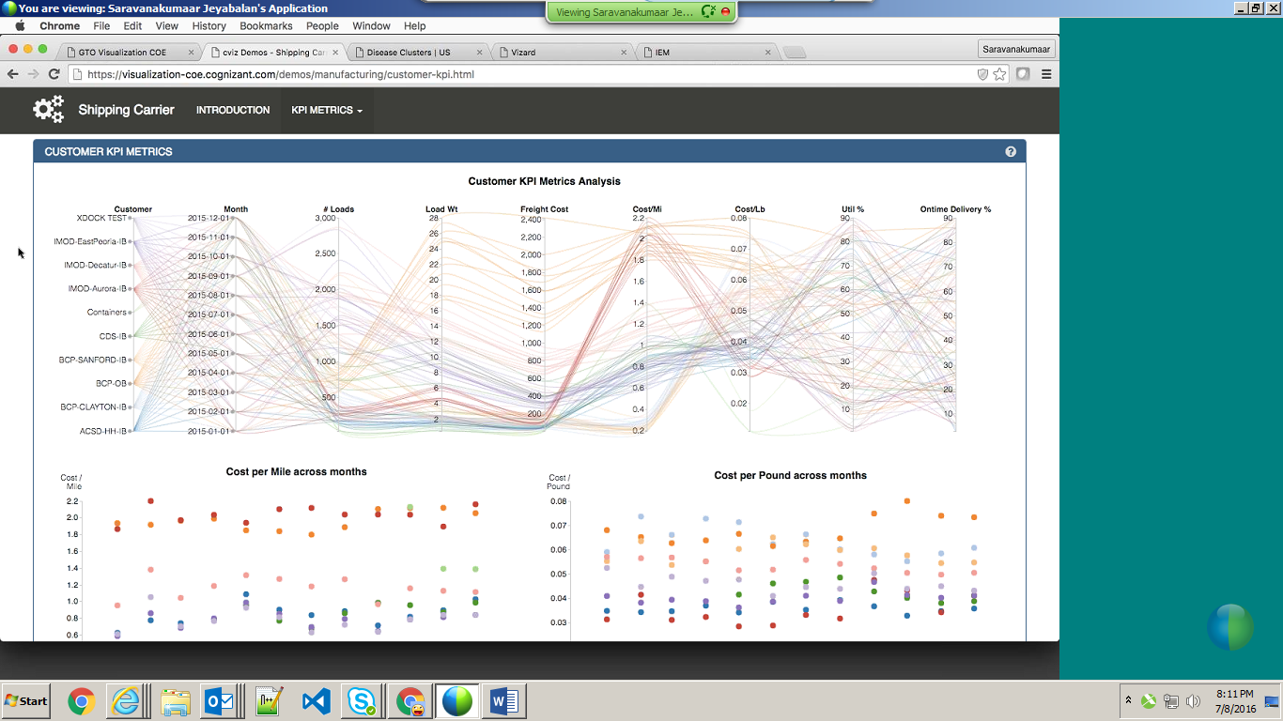

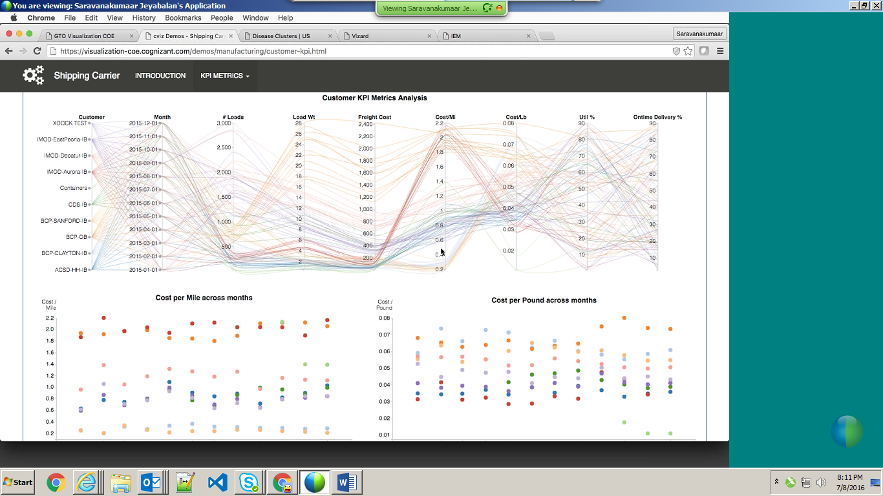

Compare only 2 customers,

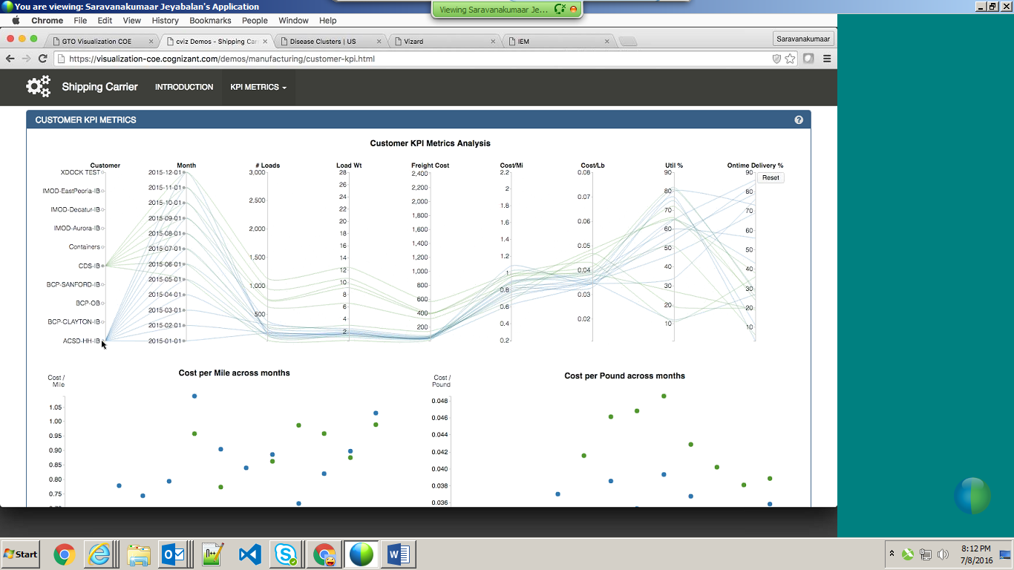

Carrier trend:

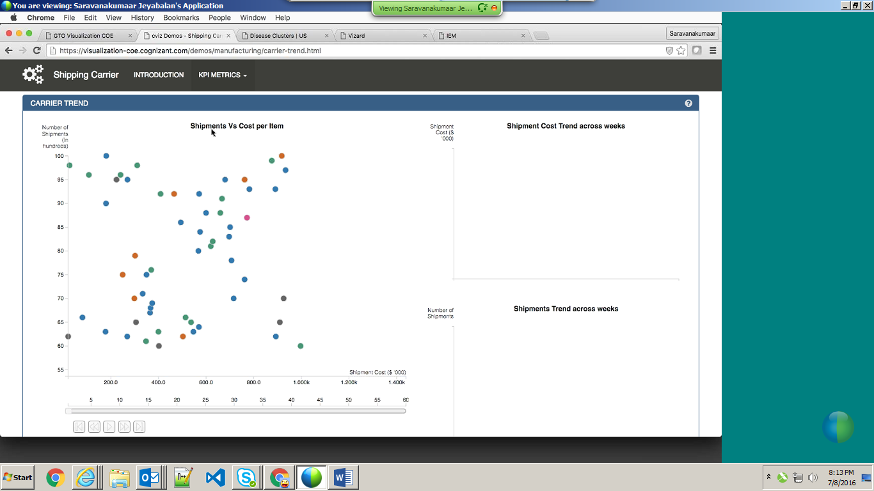

Shipment costs increased over 5 years, bubbles are moving to right hand side.

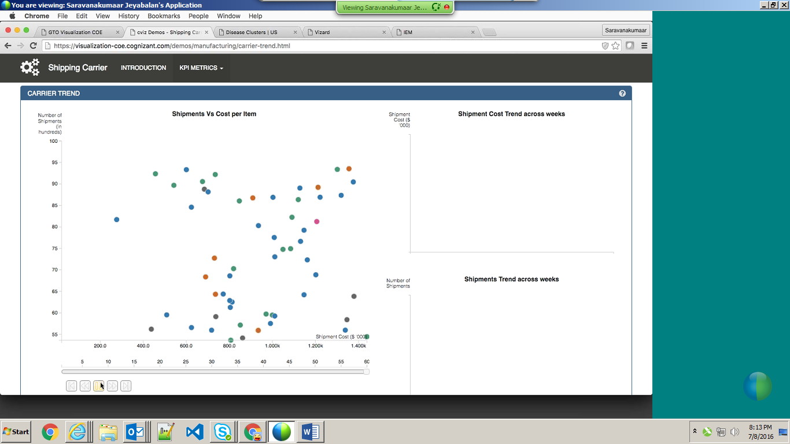

If bubble is moving left hand site, cost has been reduced.

For Healthcare customer,

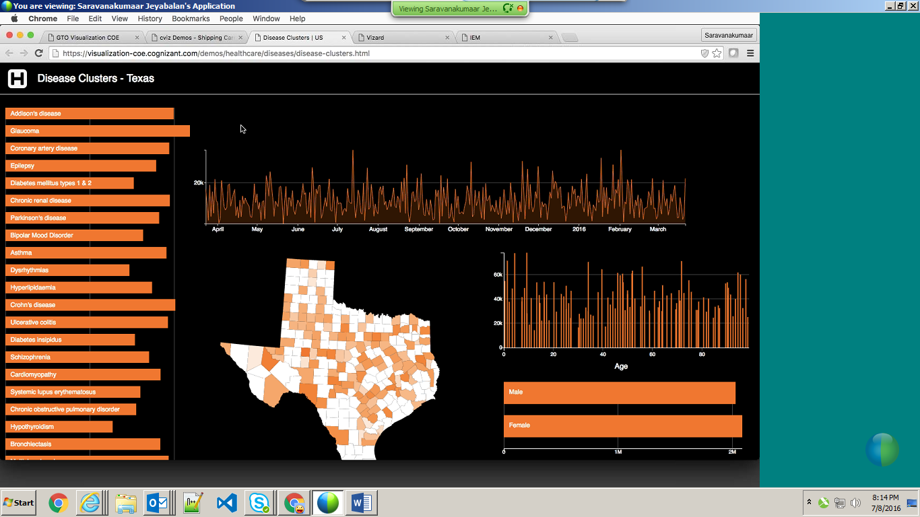

Based on disease,

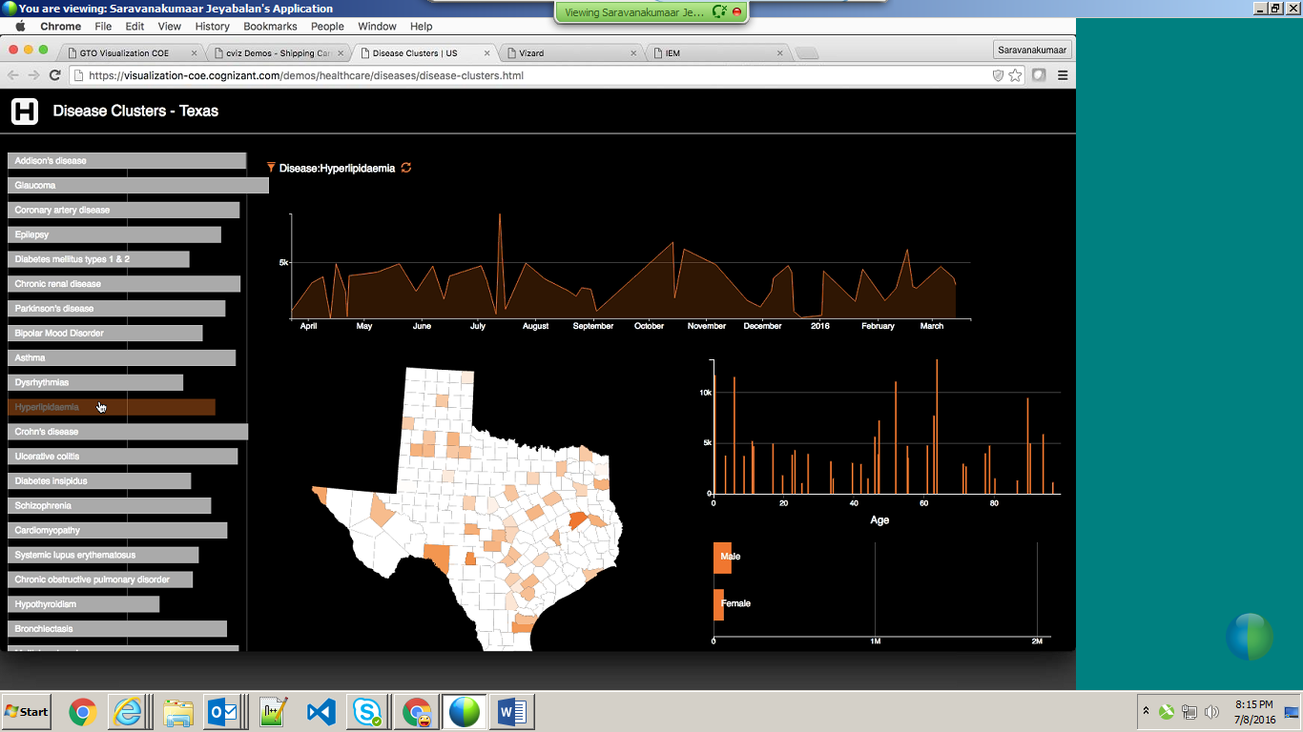

Goto microsite and access all the demos.

Developed using pure html and js lib. rendered using svg technology – scalable vector graphics. In TV also it will give good visual. Js developer has to learn/understand d3 library to develop it.

These are all html5 supported.

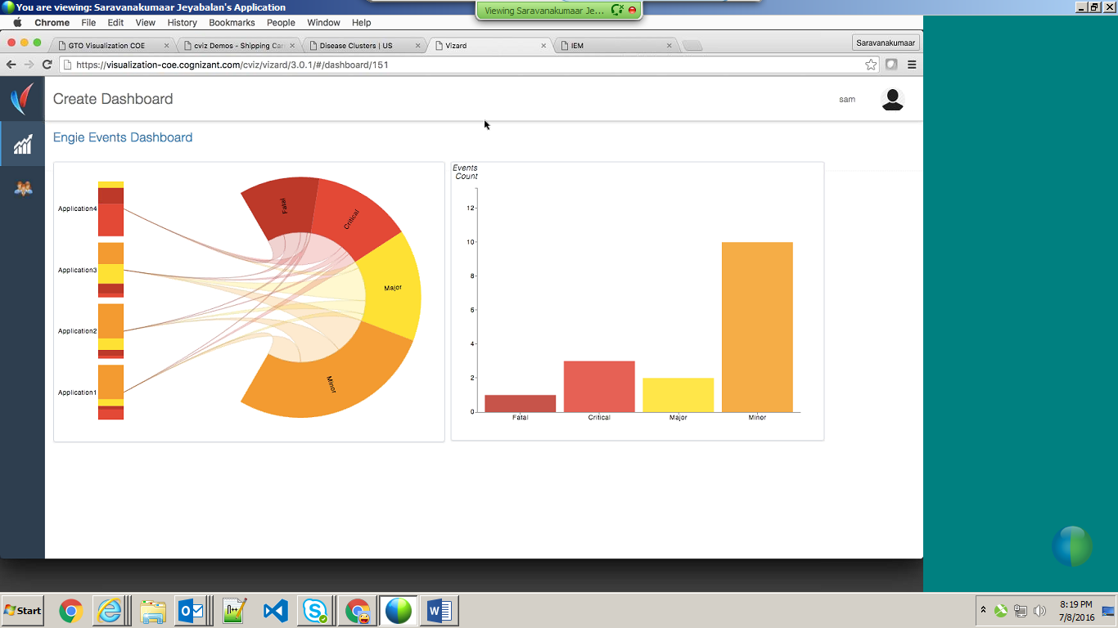

Chrome, safari will support these. IE don’t.

For particular application,

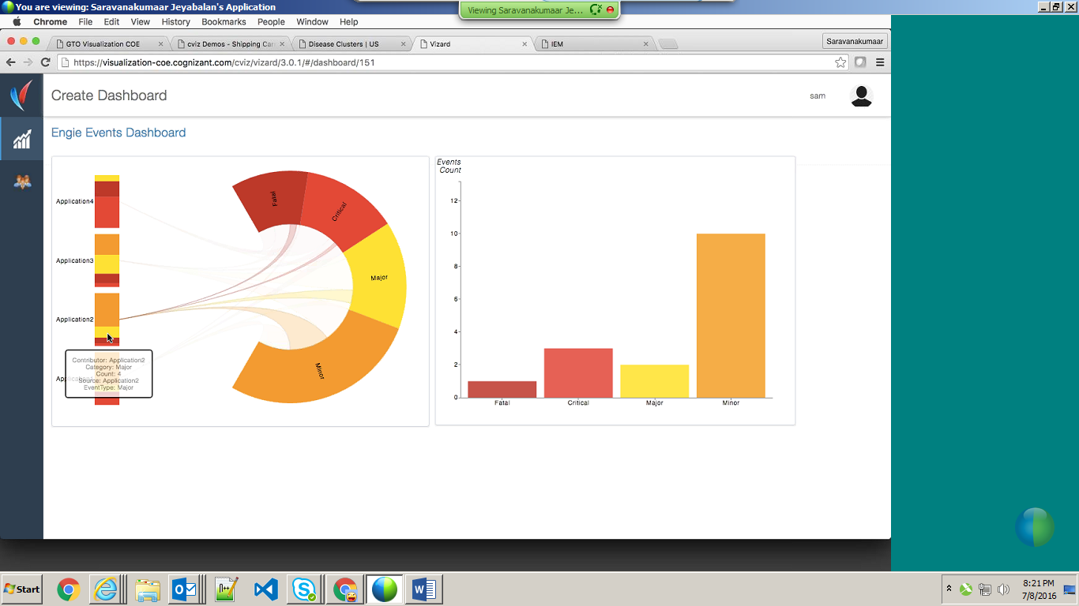

Saravanakumar jayabalan presented it.

Use existing dashboard,

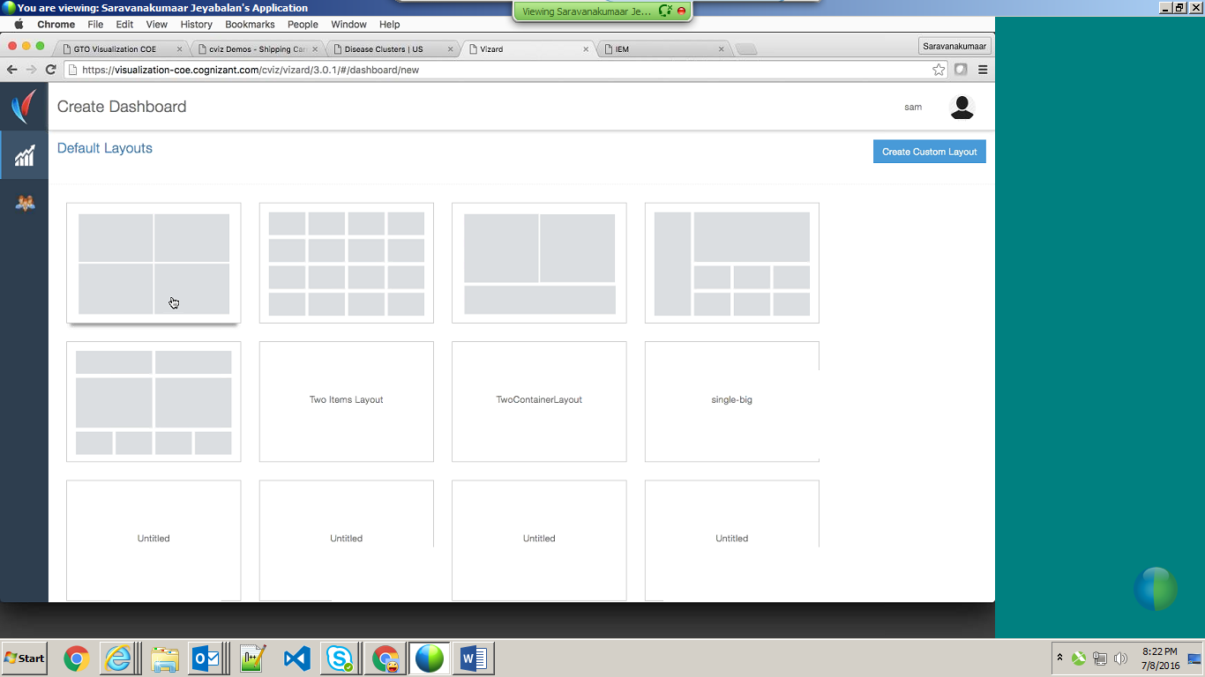

Create custom dashboard,

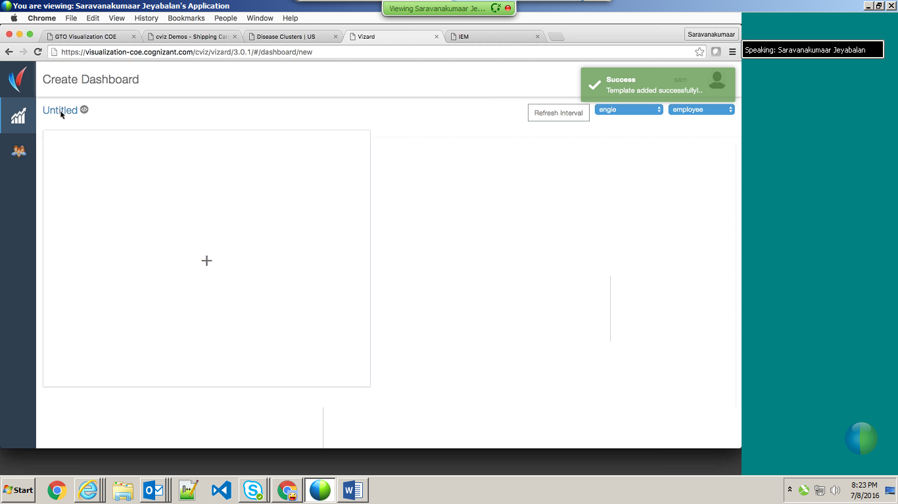

Select graph and data source,

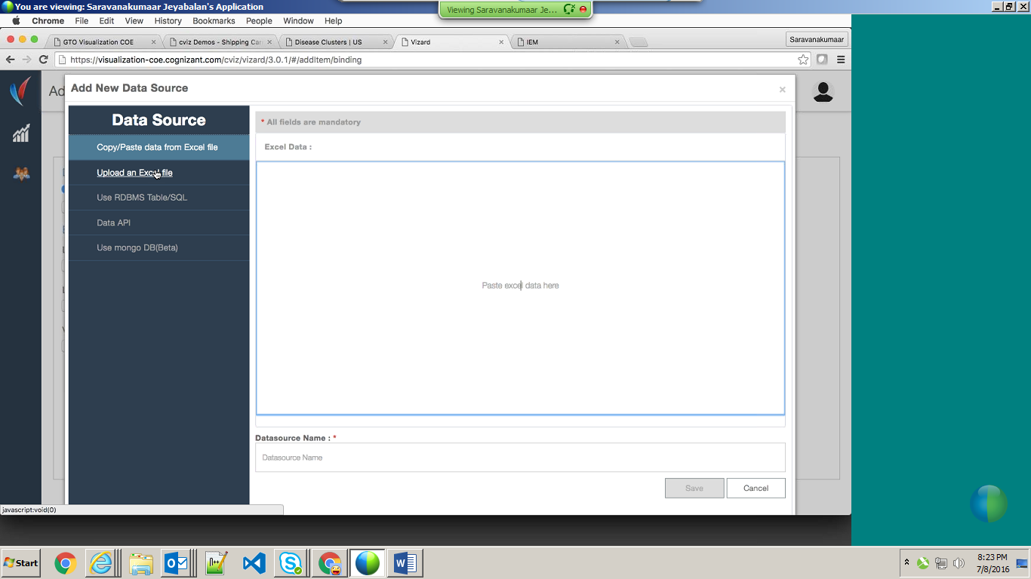

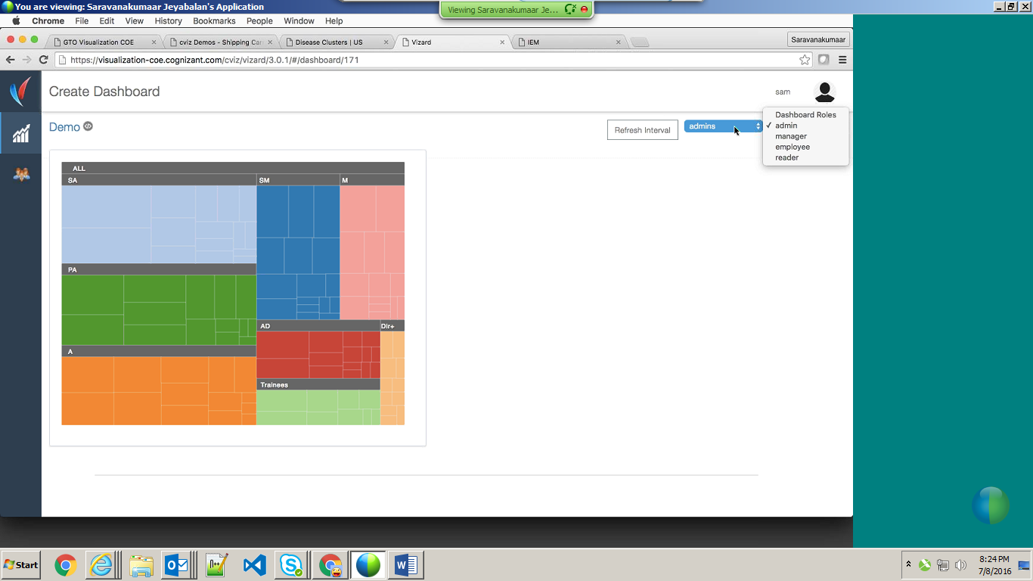

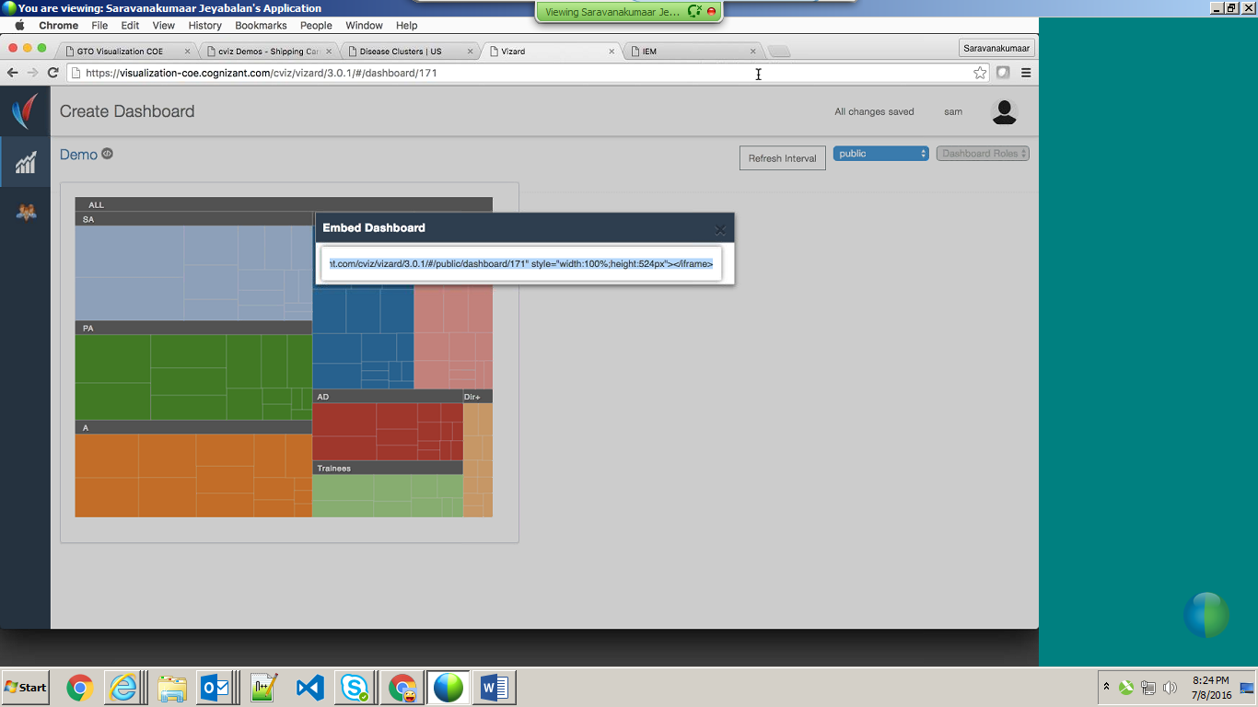

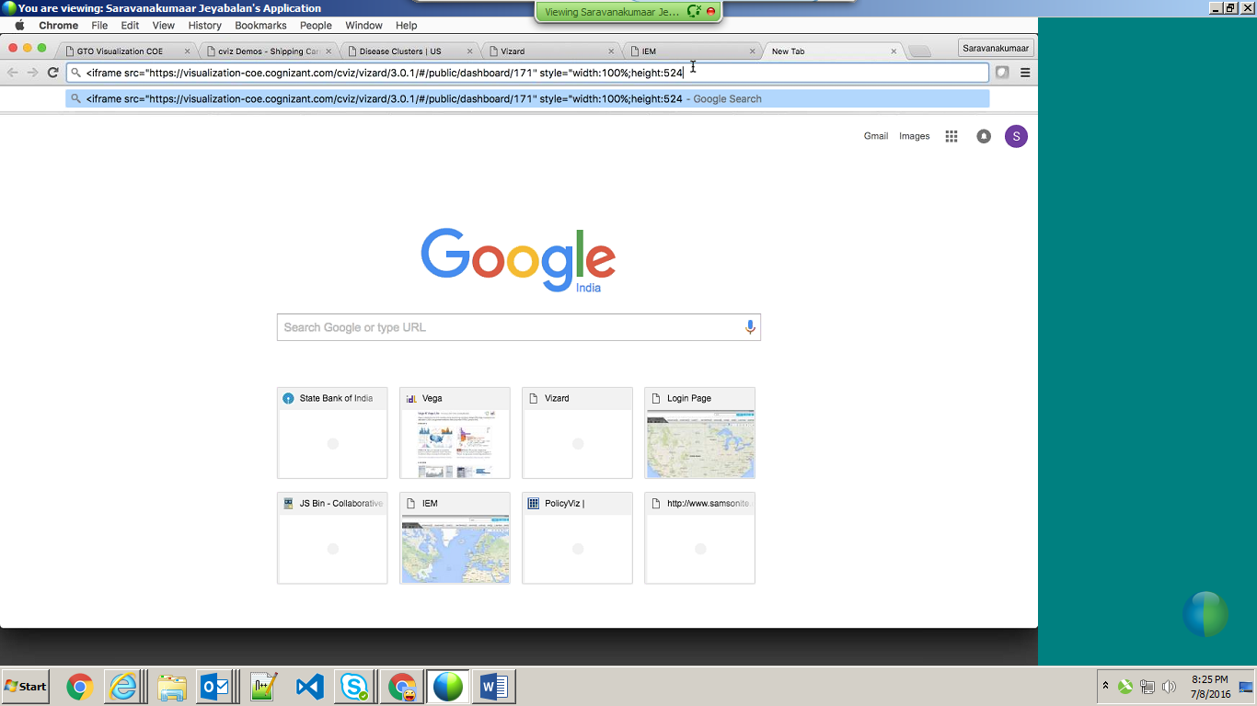

We can embed this iframe into our application

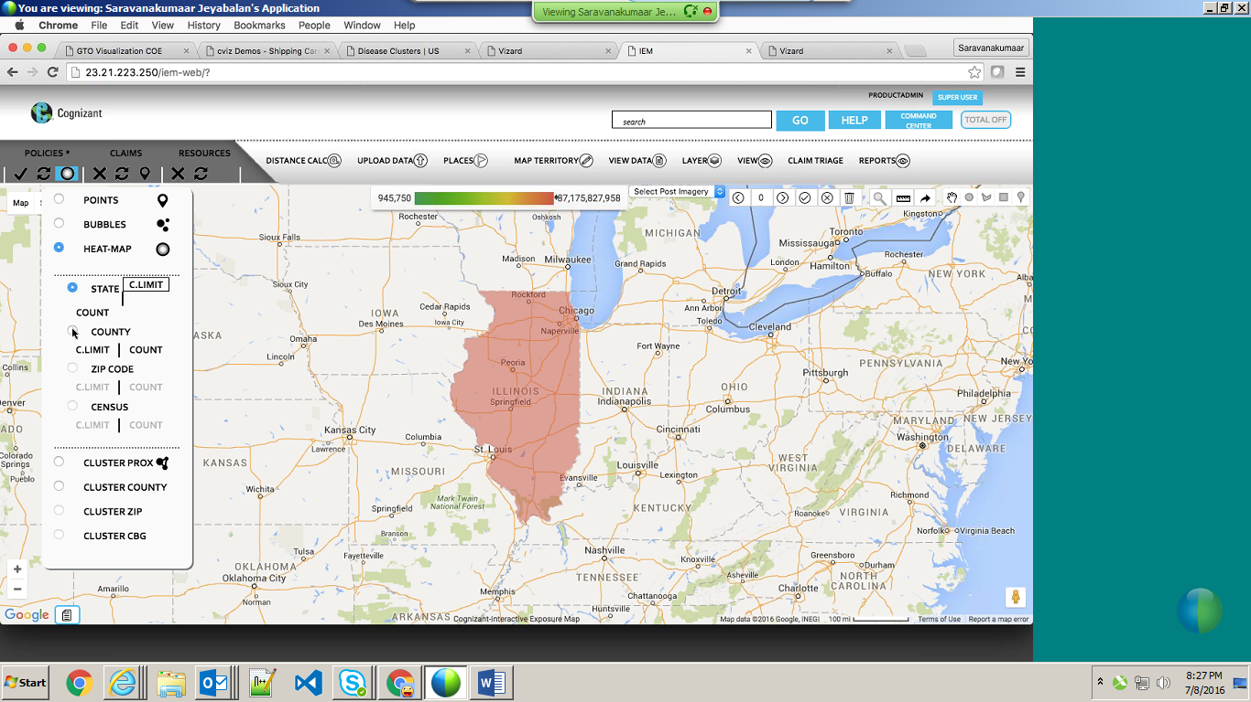

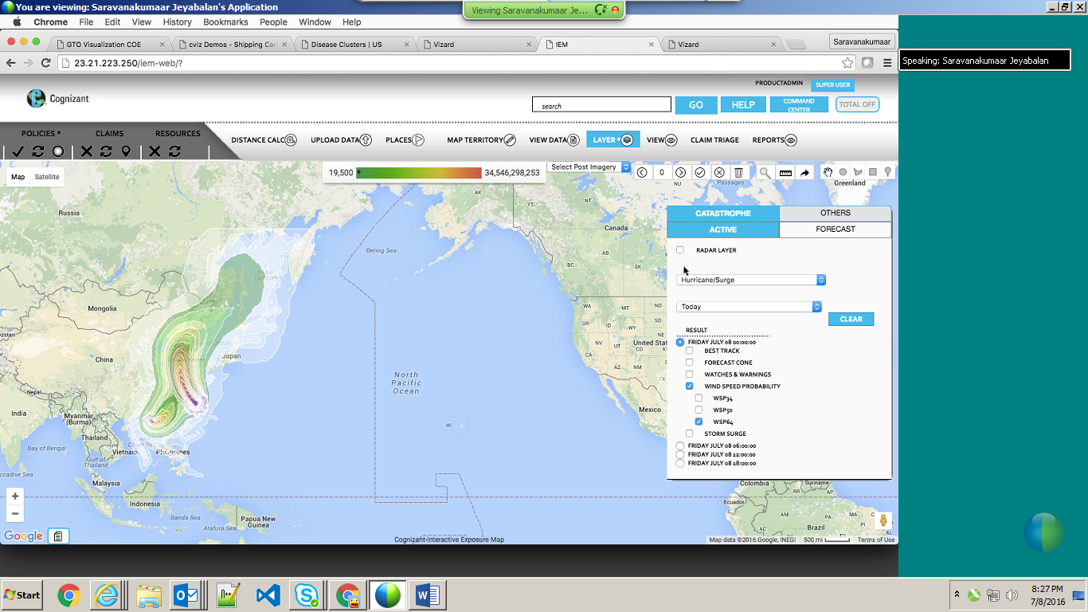

Pearl data:

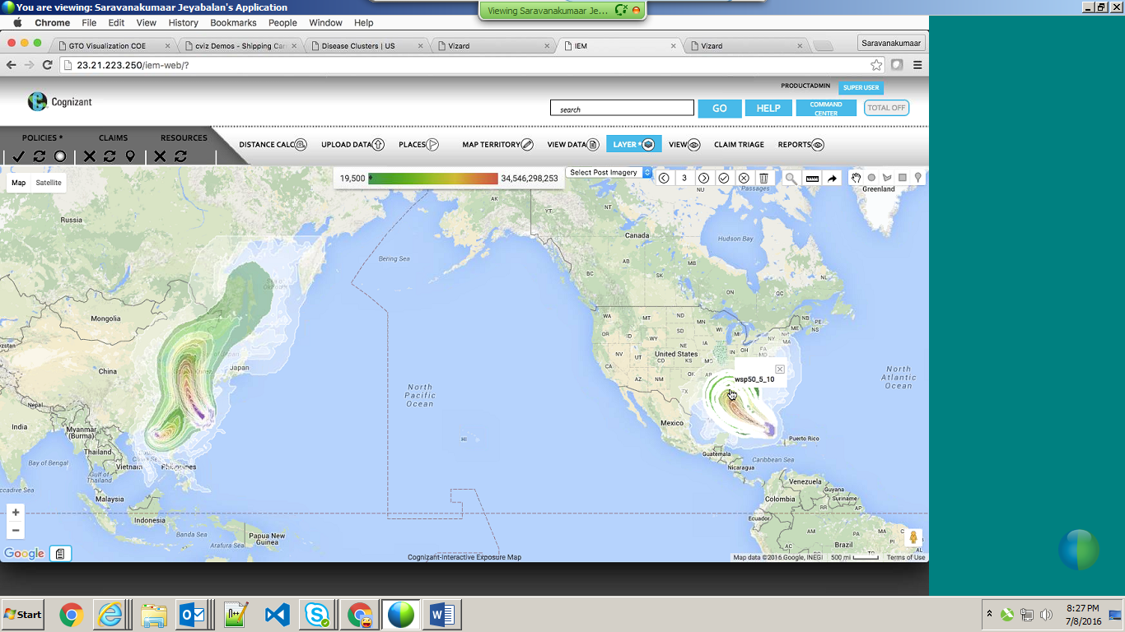

For one client, case study,

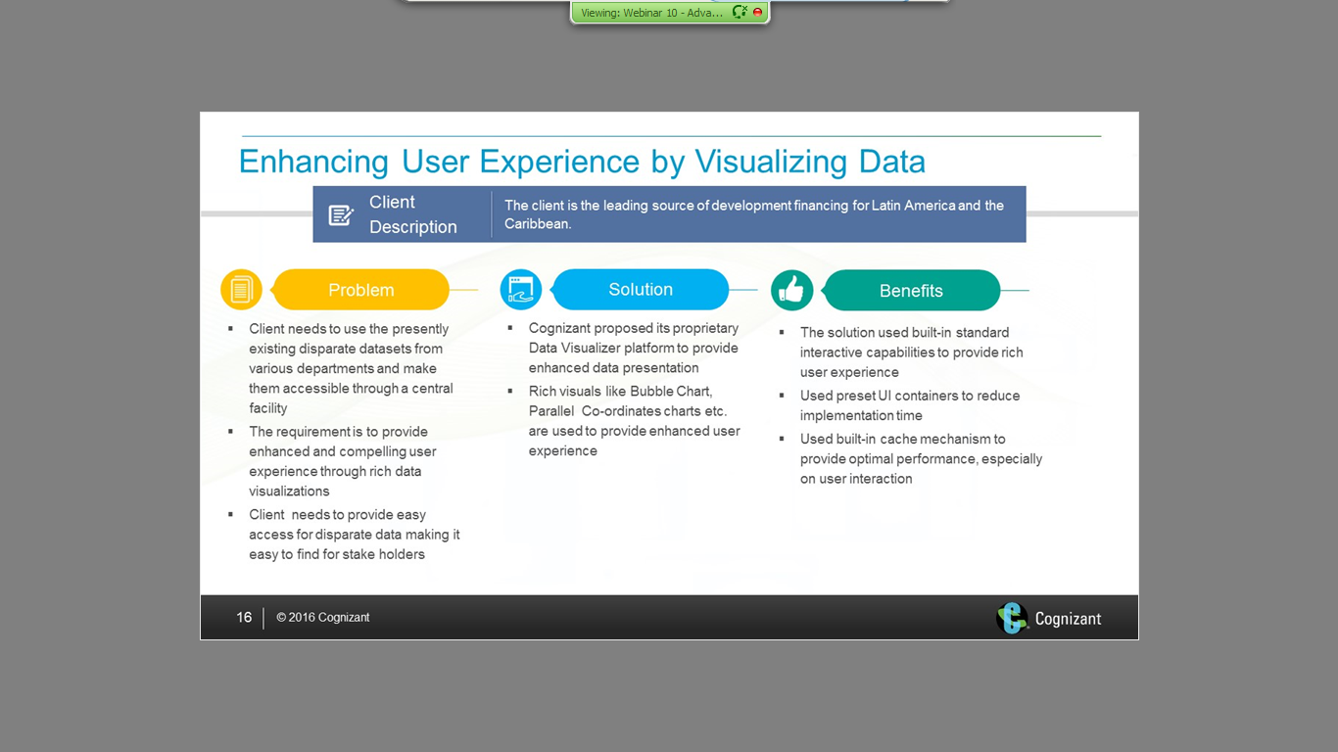

Created IEM, one case study,

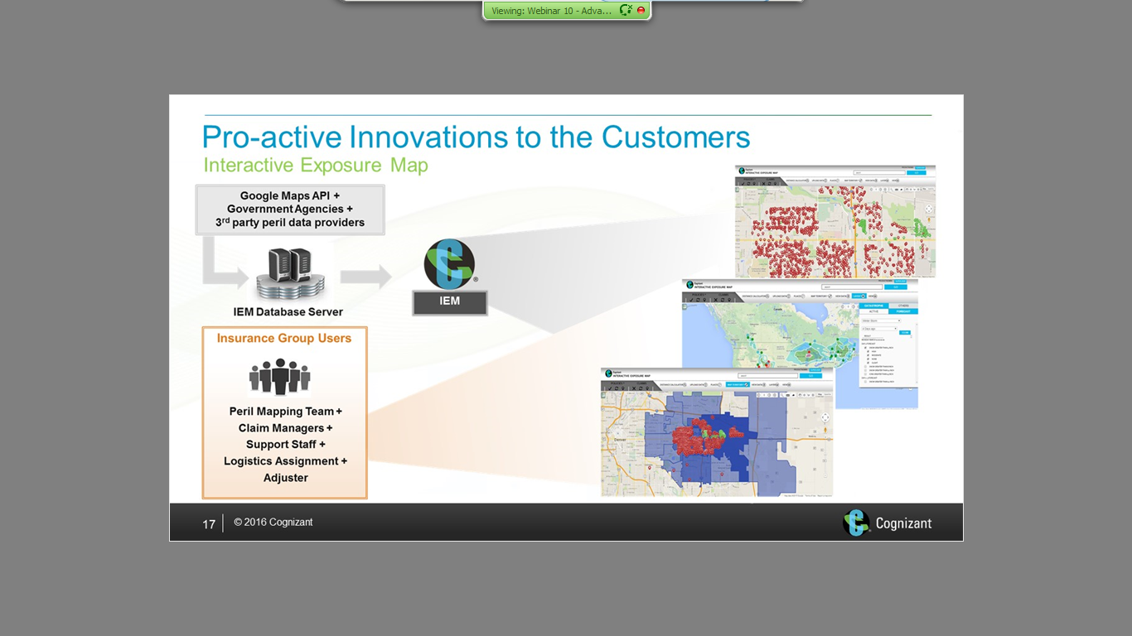

Wrong representation has been corrected by visual design engineer,

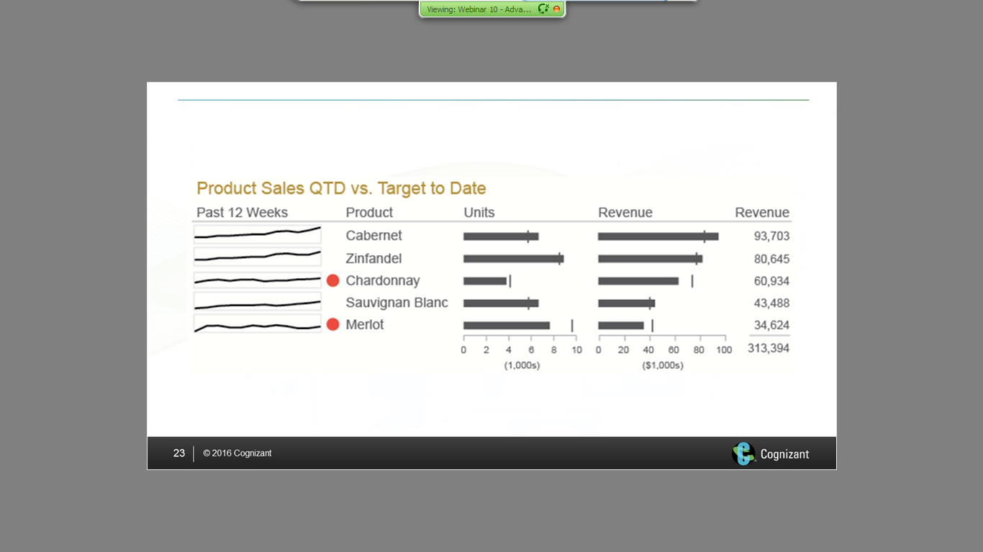

172103 - [Saravanakumaar.Jeyabalan@cognizant.com](mailto:Saravanakumaar.Jeyabalan@cognizant.com)

